Lake Shore Central School

Recommended Reading List

3-5

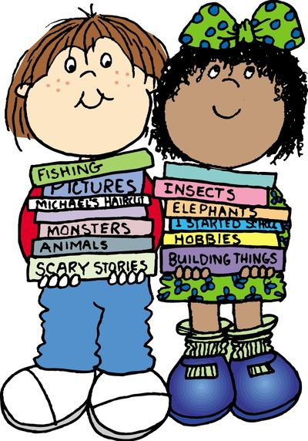

**What is a recommended reading list?**

A recommended reading list is a compilation of titles and authors that are intended to promote good reading habits. There is no greater indicator of a child’s academic success than their reading ability.

This reading list is comprised of book lists from the New York State Common Core materials alongside classical and contemporary works; including a variety of genres both fiction and non-fiction. These lists were created for independent student reading to foster life-long readers.

**You may, of course, read together:**

* By taking turns reading
* By having your child read to you
* By reading to your child

**How does a child choose a book?**

1. Choose a book that you think you will enjoy.
2. Read the second page.
3. Hold up a finger for each word you are not sure of, or do not know.
4. If there are five or more words you did not know, you should choose an easier book.

Remember, you may always ask your child’s teacher or media specialist to recommend more titles for your child to explore.

**Any book that helps a child to form a habit of reading, to make reading one of his deep and continuing needs, is good for him.**

–Maya Angelo

**Lake Shore Central Schools**

**Recommended Reading List**



**Grade 3**

**Author** **Title**

|  |  |
| --- | --- |
| Adler, David | **A Picture Book of ……series** |
| Avi | **Prairie School** |
| Bloom, Becky | **Wolf!** |
| Brett, Jan | **All Titles** |
| Bunting, Eve | **The Wednesday Surprise** |
| Cleary, Beverly | **Ramona Series** |
| Coles, Robert | **The Story of Ruby Bridges** |
| DiTerlizzi, Tony | **Spiderwick Chronicles series** |
| Gerstein, Modicai | **The Man Who Walked Between the Towers** |
| Henson, Heather | **That Book Woman** |
| LaMarche, Jim | **The Raft** |
| Lundell, Margo | **A Girl Named Helen Keller** |
| McKissack, Patricia C. | **A Picture of Freedom: The Diary of Clotee, a Slave Girl** |
| Pennypacker,Sara | **Clementine series** |
| Polacco, Patricia | **All Titles** |
| Pilkey, Dav | **Captains Underpants** |
| Roy, Ron | **A to Z Mysteries** |
| Scieszka, Jon | **Time Warp Trio series** |
| Silverstein,Shel | **Where the Sidewalk Ends, Falling Up, Light in the Attic** |
| Stilton, Geronimo | **Geronimo Stilton series** |
| Thaler, Mike | **Black Lagoon series** |
| Thomson. Sarah | **Amazing Series** |
| Van Allsburg, Chris | **All Titles** |
| Wood, Audrey and Dan | **The Napping House** |

**Lake Shore Central Schools**

**Recommended Reading List**



**Grade 4**

**Author** **Title**

|  |  |
| --- | --- |
| Balliett, Blue | **Chasing Vermeer** |
| Birdsall, Jeanne | **The Penderwicks** |
| Bruchac, Joseph | **Arrow Over the Door, Children of the Longhouse** |
| Creech, Sharon | **Love That Dog, Ruby Holler** |
| Dahl, Roald | **Charlie and the Chocolate Factory** |
| DiCamillo, Kate | **The Miraculous Journey of Edward Tulane, The Tale of Despereaux** |
| Funke, Cornelia | **Dragonrider** |
| Gutman, Dan | **Baseball Cards series** |
| Hatkoff, Polly | **Everything on a Waffle** |
| Krull, Kathleen | **All Title** |
| Juettner, Bonnie | **100 Native Americans Who Shaped History** |
| L’Engle, Madeleine | **A Wrinkle in Time** |
| Levine, Gail Caron | **Ella Enchanted** |
| Lewis, C.S. | **The Chronicle of Narnia series** |
| Maddox, Jake | **All Titles** |
| Markle, Sandra | **All nonfiction animal titles** |
| Marsh, Carole | **Real Kids, Real Places series** |
| Martenova Charles | **The Maiden of the Mist** |
| Martin, Rafe | **The World Before This one: A Novel Told in Legend** |
| Rumford, James | **Sequoyah: The Cherokee Man Who Gave His People Writing** |
| Seattle, Chief | **Brother Eagle, Sister Sky: A Message from Chief Seattle** |
| Siebold, Jan | **Rope Burn** |
| Spinelli, Jerry | **Maniac Magee** |
| Stewart, Mark | **New York Native Peoples** |
| Swamp, Chief Jake | **Giving Thanks: A Native American Good Morning Message** |
| Trumbauer, Lisa | **Life in the Time of the Fist Americans** |
| Wiles, Debrorah | **Love, Ruby Lavender, Each Little Bird That Sings** |

**Lake Shore Central Schools**

**Recommended Reading List**



**Grade 5**

**Author** **Title**

|  |  |
| --- | --- |
| Avi | **Crispin: Cross of Lead, True Confessions of Charlotte Doyle** |
| Buchanan, Andrea | **The Daring Book for Girls** |
| Chlodenko, Gennifer | **Al Capone Does My Shirts** |
| Creech, Sharon | **Walk Two Moons, the Wanderer** |
| Dahl, Roald | **The Enormous Crocodile** |
| Deedy., Carmen Agra | **14 Cows for America** |
| DuPrau, Jeanne | **The City of Ember, The People of Sparks** |
| Ellis, Deborah | **The Breadwinner** |
| Freedman, Russell | **Lincoln: A Photo-biography and other nonfiction titles** |
| Fritz, Jean | **Bully for You, Teddy Roosevelt** |
| Funke, Cornelia | **Inkheart series, The Thief Lord** |
| Giff, Patricia Reilly | **Lily’s Crossing, Nory Ryan’s Song, Pictures of Hollis Woods** |
| Green, Tim | **Football Champs** |
| Hooper, Meredith | **Who Built the Pyramids?** |
| Iggulden, Conn | **The Dangerous Book for Boys** |
| Irving, Washington | **The Legend of Sleepy Hollow** |
| Kent. Deborah | **The Freedom Riders** |
| Konigsburg, E.L. | **The View from Saturday** |
| Krull, Kathleen | **Giants of Science biographies** |
| Lowry, Lois | **Number the Stars** |
| Lunge-Larsen, Lise | **Gifts from the Gods** |
| Murphy, Jim | **A Young Patriot, The Boys’ War, and other nonfiction titles** |
| Naylor, Phyllis Reynold | **Shiloh** |
| Nelson, Kadir | **We are the Ship: The Story of Negro League Baseball** |
| O’Brien, Tony | **Afghan Dreams** |
| Paulsen, Gary | **Hatchet, Nightjohn** |
| Rowling, J.K. | **Harry Potter series** |
| Sachar, Louis | **Holes** |
| Selznick, Brian | **The Invention of Hugo Cabret** |
| Sis, Peter | **The Wall** |
| Venezia, Mike | **Jane Goodall: Researcher who Champions Chimps** |